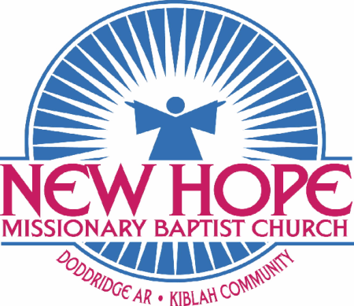 | WORK
MARCH 2019 | Volume 26 Number 1
In This Issue  - Equipped by God– In Touch.org  - Prayer List  - Calendar of Events  - Contact Us  Contact Us  www.nhmbckiblah.org    620 MC 192  Doddridge, Arkansas 71834  870-691-2872 Church  870-691-3069 Pastor  Contact Us  www.nhmbckiblah.org      620 MC 192  Doddridge, Arkansas 71834  870-691-2872 Church  870-691-3069 Pastor  Contact Us  www.nhmbckiblah.org    620 MC 192  Doddridge, Arkansas 71834  870-691-2872 Church  870-691-3069 Pastor  Contact Us  www.nhmbckiblah.org    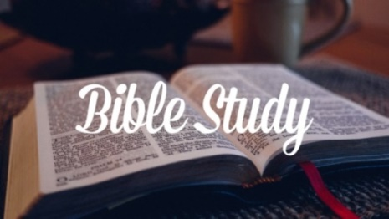 | EQUIPPED BY GOD  Hebrews 13:20-21  Sometimes followers of Christ get the wrong idea about their role versus God’s role. They may think that God is sitting on His throne, waiting to meet their needs when they call on Him. Although He is a loving Father who provides for us, we must be careful not to assume He exists to serve us.  The reality is that we exist for God. He created us for His purposes and has equipped every believer to serve Him in some fashion. According to Ephesians 2:10, “We are His workmanship, created in Christ Jesus for good works, which God prepared beforehand so that we would walk in them.” Everything about us has been designed by God to equip us for the work He preordained long before our birth.  • He created each of us with the exact personality and body we would need to fulfill His purpose for our life.  • God has equipped us with the strengths, abilities, and talents necessary to do what He planned for us.  • The Holy Spirit has given us spiritual gifts with which to serve one another in the church.  • Every experience in our life is used by God to equip us for doing His will. Both the pleasant and difficult times shape our character, mature us spiritually, and train us to help others.  God uniquely created each of us, and He’s provided us with everything we need to serve and glorify Him. All we must do is step out in obedience with full reliance on His grace and power.  Prayer List  Pastor Boone, 1st Lady & Family Our Country  Mother Jessie Henderson Our Community  Mother Audria Sewell Our Church  Mother Lela Harris Our President  Sister Clara Gulley Our Government  Sister Margee Ree Brown Our Military  Sister Flora James Our City  Sister Emma Darden Our Home Delivered  Mr. & Mrs. Henry Williams Meals Ministry  Mrs. Olevia Legardye Our Nursing Home Ministry  Brother Roosevelt Williams Our Prison Ministry  Mr. & Mrs. Charles Patton  CALENDAR OF EVENTS  March 3 3pm Deacon Ordination of Bro. Marion “Doug” Burks, Sr. Rev. Eric Stells & New Shiloh B.C. are our special guests.  March 10 Daylight Saving Time Begins – Spring Forward  March 10 6pm Ozan Baptist District Association – Monthly Fellowship.  March 17 3pm Pastor Boone & NHMBC are the special guests of Wynn Missionary Baptist Church, Garland, AR for the 1st Pastoral Appreciation Service of Pastor James & First Lady Tameka Harris.  March 31 3pm Pastor Boone & NHMBC are the special guests of New Shiloh B.C. for their Dedication Program.  What Takes Place After Salvation  John 3:16-17  To truly grasp what Jesus did for us on the cross—and to be able to share the gospel effectively—it’s essential to have an accurate understanding of the terms we use to describe salvation.  Saved (Eph. 2:8). This is a synonym for rescued. Mankind needs rescuing because without Jesus, we are all destined for divine wrath, hell, and eternal separation from God.  Redeemed (Eph. 1:7). Redemption implies a transaction. Our salvation was purchased through the shedding of Jesus Christ’s blood.  Justified (Rom. 5:1). When someone trusts in Christ, God pardons that person and removes his or her guilt. A saved individual is in right standing with the Lord.  Reconciled (2 Corinthians 5:18-21). Salvation results in a relationship with God. We were once separated from Him, but now we are His sons and daughters, and He calls us His friends (John 15:15).  Using words like redemption, justification, and reconciliation might not be effective when presenting the gospel to someone unfamiliar with the language often used in church. However, it’s important for us to understand what the Bible teaches about salvation, and these terms give us a framework for explaining the good news to others.  We must recognize that we are not saved by our personal works or performance. Salvation is ours by God’s grace—His unmerited, undeserved, loving favor toward us—and at the cost of Jesus’ own blood. Let us not take for granted how God has rescued us: by sending His Son to die in our place.  From the Desk of Your Pastor  Greetings in the Name of our Lord and Savior Jesus Christ. I pray that all is well with your soul. As I was praying this morning, God laid upon my heart to share with you that He wants us, our local church body, to come closer together. We should be so close that we bear one another burdens. The bible says “Behold, how good and how pleasant it is for brethren to dwell together in unity. Our local body has had many setbacks over the years, but God has always sustained us and He is bringing us back together as one. If our community and surrounding communities are divided, it’s going to take the local body to bring us all back together. A thought to remember is that unity starts in the church. You will see another Penecostal explosion, when the Body of Christ comes together on one accord. God is willing and waiting and believe it or not, it starts with us.  In closing, I want to share with you the goals that I believe will be accomplished this year:  - New color copier – accomplished  - Television in the foyer with our announcements on them. Television has been purchased.  - Church budget going forward  - Electronic sign  - Brotherhood Breakfast  - Women’s Conference  - Musical – we have been deficient in that area  - Prison Ministry – start back up  - Tablets for all deacons who are computer literate-basic skills to operate a computer.  These are attainable goals  United by His Blood  Pastor Boone

